**LAPORAN PRAKTIKUM**

**BAHASA PEMROGRAMAN 1**

(**DOSEN PENGAMPU : DEDE HUSEN., M.KOM)**

**Modul 7 & 8**



DISUSUN OLEH :

NAMA : MOHAMAD ABAN SY’BANA

NIM : 20230810012

KELAS : TINFC-2023-04

**TEKNIK INFORMATIKA**

**FAKULTAS ILMU KOMPUTER**

**UNIVERSITAS KUNINGAN**

**2024**

**Modul 7**

**PRETES**

1. Tulis dan jelaskan dengan singkat komponen dari JDBC API!

**Jawab :**

1. Driver Manager:
   * Bertanggung jawab untuk mengelola daftar driver database. Driver Manager mencoba menghubungkan aplikasi ke database yang sesuai melalui driver yang telah terdaftar.
2. Driver:
   * Antarmuka yang harus diimplementasikan oleh semua driver database JDBC. Driver bertugas mengelola koneksi antara aplikasi Java dan database.
3. Connection:
   * Menggambarkan sesi koneksi ke database tertentu. Melalui objek Connection, Anda dapat membuat pernyataan SQL dan mengelola transaksi.
4. Statement:
   * Digunakan untuk mengeksekusi pernyataan SQL statis dan mengembalikan hasil dari eksekusi tersebut. Terdapat tiga jenis Statement: Statement, PreparedStatement, dan CallableStatement.
5. ResultSet:
   * Menggambarkan hasil dari pernyataan SQL SELECT. ResultSet menyediakan metode untuk mengakses kolom nilai yang dihasilkan.
6. SQLException:
   * Kelas yang digunakan untuk menangani kesalahan terkait database. SQLException memberikan informasi rinci mengenai kesalahan yang terjadi saat berinteraksi dengan database.

**PRAKTIKUM**

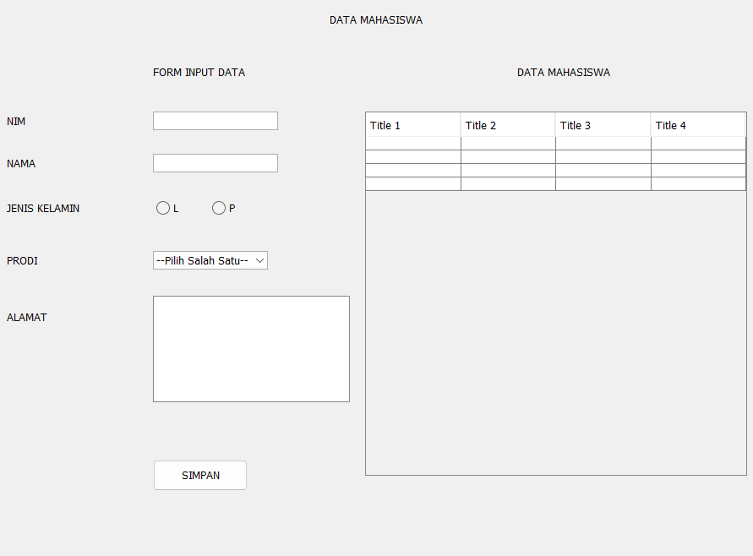

**POSTES**

1. Lengkapi Program, Jika tombol simpan di klik akan menampilkan YesNoQuestion untuk penyimpanan data.

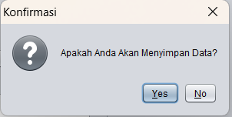

1. Jika tombol simpan di klik, form input data akan Kembali kosong seperti kondisi awal

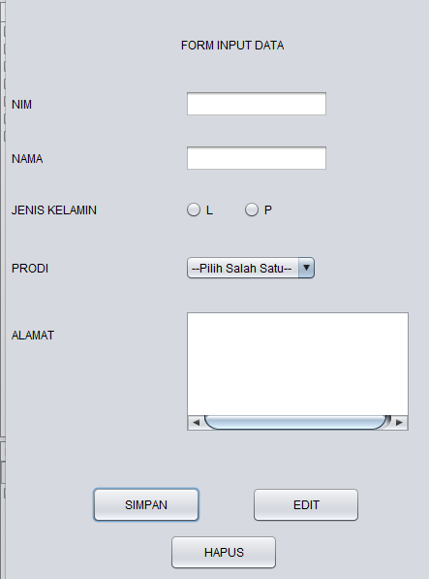

1. Jika tombol simpan di klik, data yang di input akan langsung tampil pada JTable.

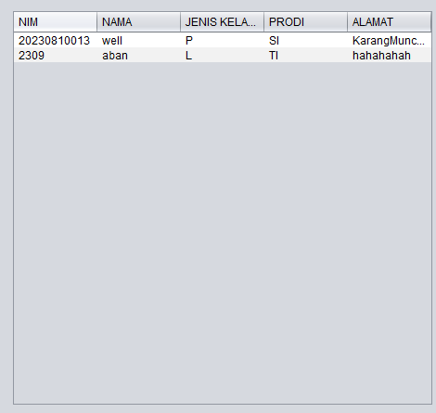

**TUGAS**

1. Lengkapi Program, jika tombol simpan di klik tetapi ada data yang belum terisi maka akan menampilkan pesan “Data Harus Diisi!”

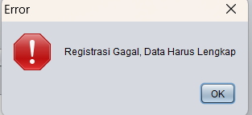

1. Lengkapi Button edit dan hapus

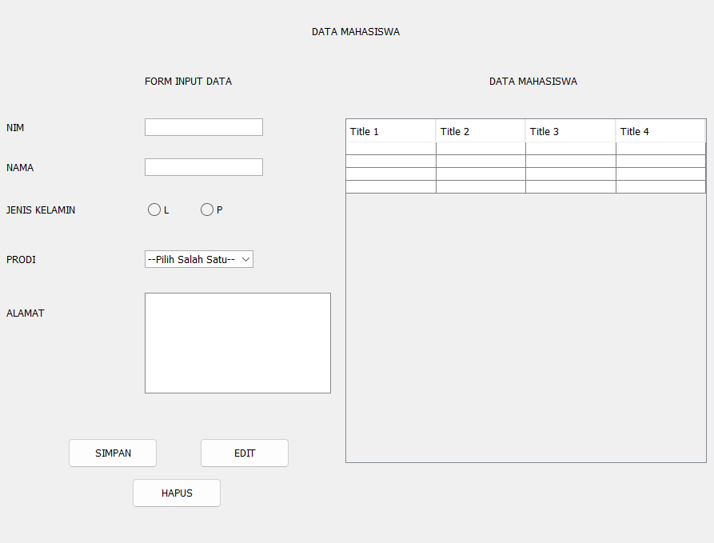

**Modul 8**

**Pretes**

1. Tuliskans sql query untuk input,simpan,update, dan delete !

Jawab :

CREATE TABLE IF NOT EXISTS users (

id INT AUTO_INCREMENT PRIMARY KEY,

name VARCHAR(255) NOT NULL,

email VARCHAR(255) NOT NULL UNIQUE

);

INSERT INTO users (name, email) VALUES ('aban', 'abanganteng43@gmail.com');

SELECT * FROM users;

SELECT * FROM users WHERE id = 1;

UPDATE users

SET name = 'aban', email = 'abanterlaluganteng43@gmail.com'

WHERE id = 1;

DELETE FROM users WHERE id = 1;

**Praktikum**



**Postes**

1. Lengkapi program, jika tombol edit di klik akan menampilkan message dialog YesNoQuestion untuk edit data.

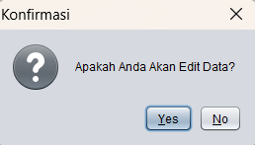

1. Lengkapi program, jika tombol hapus di klik akan menampilkan message dialog YesNoQuestion untuk hapus data.

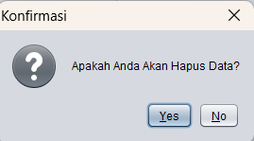

1. Lengkapi program, jika tombol edit/hapus di klik form input data akan Kembali kosong sepeti kondisi awal

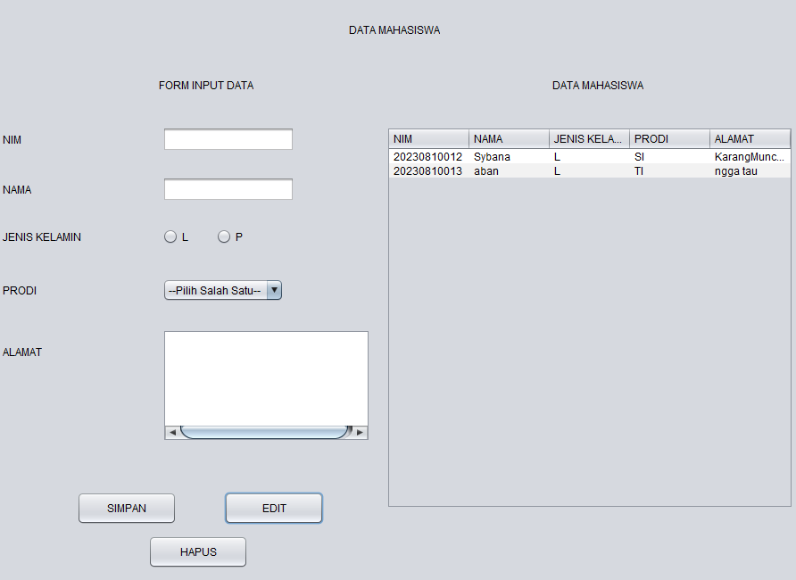

1. Setelah edit/hapus,maka JTable akan melakukan load data

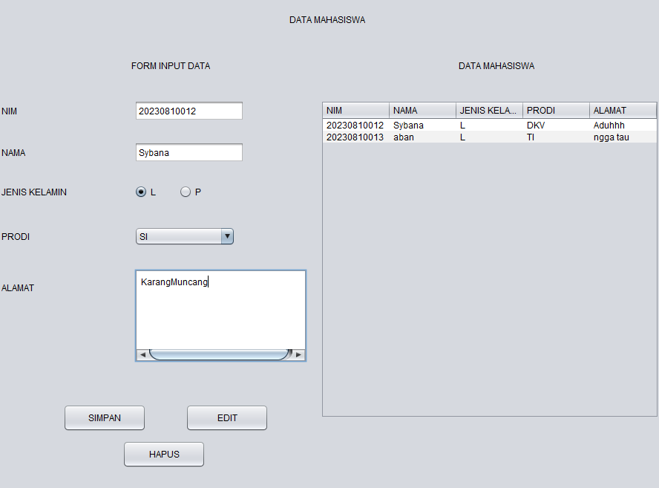

**Code nya**

package bp1_m7_p1;

import java.sql.ResultSet;

import java.sql.SQLException;

import java.sql.Statement;

import javax.swing.JOptionPane;

import javax.swing.table.DefaultTableModel;

/**

*

* @author Suci Indah Lestari

*/

public class bp1_M7_p1 extends javax.swing.JFrame {

private Object JTable1;

Statement st;

ResultSet rs;

koneksi koneksi;

/**

* Creates new form BP1_M6_P1_aban

*/

bp1_M7_p1() {

initComponents();

koneksi = new koneksi(); // Inisialisasi koneksi

load_data();

}

private void load_data() {

Object header[] = {"NIM", "NAMA", "JENIS KELAMIN", "PRODI", "ALAMAT"};

DefaultTableModel data = new DefaultTableModel(null, header);

jTable1.setModel(data);

String sql = "SELECT nim, nama, jk, prodi, alamat FROM from_mhs";

try{

st = koneksi.con.createStatement();

rs = st.executeQuery(sql);

while(rs.next()){

String k1 = rs.getString("nim");

String k2 = rs.getString("nama");

String k3 = rs.getString("jk");

String k4 = rs.getString("prodi");

String k5 = rs.getString("alamat");

String k[] = {k1, k2, k3, k4, k5};

data.addRow(k);

}

} catch (Exception e) {

JOptionPane.showMessageDialog(null, e);

}

}

public void InputData() {

try {

String JK = "";

if (jRadioButton1.isSelected()) {

JK = jRadioButton1.getText();

} else if (jRadioButton2.isSelected()) {

JK = jRadioButton2.getText();

}

// Validasi input

if (jTextField1.getText().isEmpty() || jTextField2.getText().isEmpty() || JK.isEmpty()

|| jComboBox1.getSelectedIndex() == 0 || jTextArea1.getText().isEmpty()) {

JOptionPane.showMessageDialog(this, "Registrasi Gagal, Data Harus Lengkap", "Error",

JOptionPane.ERROR_MESSAGE);

return;

}

String sql = "INSERT INTO from_mhs (nim, nama, jk, prodi, alamat) VALUES ('"

+ jTextField1.getText() + "', '" + jTextField2.getText() + "', '" + JK + "', '"

+ jComboBox1.getSelectedItem() + "', '" + jTextArea1.getText() + "')";

// Opsi Simpan Data

int Opsi = JOptionPane.showConfirmDialog(this, "Apakah Anda Akan Menyimpan Data?", "Konfirmasi",

JOptionPane.YES_NO_OPTION);

if (Opsi == JOptionPane.YES_OPTION) {

st.execute(sql);

JOptionPane.showMessageDialog(this, "Data berhasil disimpan.");

clear_data();

} else {

JOptionPane.showMessageDialog(this, "Data tidak disimpan.");

}

} catch (SQLException e) {

JOptionPane.showMessageDialog(this, e.getMessage(), "Error", JOptionPane.ERROR_MESSAGE);

}

}

private void clear_data() {

jTextField1.setText("");

jTextField2.setText("");

buttonGroup1.clearSelection();

jComboBox1.setSelectedIndex(0);

jTextArea1.setText("");

}

/**

* This method is called from within the constructor to initialize the form.

* WARNING: Do NOT modify this code. The content of this method is always

* regenerated by the Form Editor.

*/

@SuppressWarnings("unchecked")

// <editor-fold defaultstate="collapsed" desc="Generated Code">

private void initComponents() {

buttonGroup1 = new javax.swing.ButtonGroup();

jLabel1 = new javax.swing.JLabel();

jLabel2 = new javax.swing.JLabel();

jLabel3 = new javax.swing.JLabel();

jLabel4 = new javax.swing.JLabel();

jLabel5 = new javax.swing.JLabel();

jLabel6 = new javax.swing.JLabel();

jTextField1 = new javax.swing.JTextField();

jTextField2 = new javax.swing.JTextField();

jComboBox1 = new javax.swing.JComboBox<>();

jRadioButton1 = new javax.swing.JRadioButton();

jRadioButton2 = new javax.swing.JRadioButton();

jScrollPane1 = new javax.swing.JScrollPane();

jTextArea1 = new javax.swing.JTextArea();

jButton1 = new javax.swing.JButton();

jScrollPane2 = new javax.swing.JScrollPane();

jTable1 = new javax.swing.JTable();

jLabel7 = new javax.swing.JLabel();

jLabel8 = new javax.swing.JLabel();

jButton2 = new javax.swing.JButton();

jButton3 = new javax.swing.JButton();

setDefaultCloseOperation(javax.swing.WindowConstants.EXIT_ON_CLOSE);

jLabel1.setText("FORM INPUT DATA");

jLabel2.setText("NIM");

jLabel3.setText("NAMA");

jLabel4.setText("JENIS KELAMIN");

jLabel5.setText("PRODI");

jLabel6.setText("ALAMAT");

jComboBox1.setModel(new javax.swing.DefaultComboBoxModel<>(new String[] { "--Pilih Salah Satu--", "TI", "SI", "DKV", "TS", "MI" }));

buttonGroup1.add(jRadioButton1);

jRadioButton1.setText("L");

buttonGroup1.add(jRadioButton2);

jRadioButton2.setText("P");

jTextArea1.setColumns(20);

jTextArea1.setRows(5);

jScrollPane1.setViewportView(jTextArea1);

jButton1.setText("SIMPAN");

jButton1.addMouseListener(new java.awt.event.MouseAdapter() {

public void mouseClicked(java.awt.event.MouseEvent evt) {

jButton1MouseClicked(evt);

}

});

jButton1.addActionListener(new java.awt.event.ActionListener() {

public void actionPerformed(java.awt.event.ActionEvent evt) {

jButton1ActionPerformed(evt);

}

});

jTable1.setModel(new javax.swing.table.DefaultTableModel(

new Object [][] {

{null, null, null, null},

{null, null, null, null},

{null, null, null, null},

{null, null, null, null}

},

new String [] {

"Title 1", "Title 2", "Title 3", "Title 4"

}

));

jScrollPane2.setViewportView(jTable1);

jLabel7.setText("DATA MAHASISWA");

jLabel8.setText("DATA MAHASISWA");

jButton2.setText("EDIT");

jButton2.addMouseListener(new java.awt.event.MouseAdapter() {

public void mouseClicked(java.awt.event.MouseEvent evt) {

jButton2MouseClicked(evt);

}

});

jButton2.addActionListener(new java.awt.event.ActionListener() {

public void actionPerformed(java.awt.event.ActionEvent evt) {

jButton2ActionPerformed(evt);

}

});

jButton3.setText("HAPUS");

jButton3.addMouseListener(new java.awt.event.MouseAdapter() {

public void mouseClicked(java.awt.event.MouseEvent evt) {

jButton3MouseClicked(evt);

}

});

jButton3.addActionListener(new java.awt.event.ActionListener() {

public void actionPerformed(java.awt.event.ActionEvent evt) {

jButton3ActionPerformed(evt);

}

});

javax.swing.GroupLayout layout = new javax.swing.GroupLayout(getContentPane());

getContentPane().setLayout(layout);

layout.setHorizontalGroup(

layout.createParallelGroup(javax.swing.GroupLayout.Alignment.LEADING)

.addGroup(layout.createSequentialGroup()

.addContainerGap()

.addGroup(layout.createParallelGroup(javax.swing.GroupLayout.Alignment.LEADING)

.addComponent(jLabel2)

.addComponent(jLabel3)

.addComponent(jLabel5)

.addComponent(jLabel4)

.addComponent(jLabel6))

.addGap(87, 87, 87)

.addComponent(jLabel1)

.addPreferredGap(javax.swing.LayoutStyle.ComponentPlacement.RELATED, javax.swing.GroupLayout.DEFAULT_SIZE, Short.MAX_VALUE)

.addComponent(jLabel7)

.addGap(174, 174, 174))

.addGroup(layout.createSequentialGroup()

.addGap(394, 394, 394)

.addComponent(jLabel8)

.addGap(0, 0, Short.MAX_VALUE))

.addGroup(layout.createSequentialGroup()

.addGroup(layout.createParallelGroup(javax.swing.GroupLayout.Alignment.LEADING)

.addGroup(layout.createSequentialGroup()

.addGap(185, 185, 185)

.addGroup(layout.createParallelGroup(javax.swing.GroupLayout.Alignment.LEADING)

.addComponent(jTextField1, javax.swing.GroupLayout.PREFERRED_SIZE, 148, javax.swing.GroupLayout.PREFERRED_SIZE)

.addGroup(layout.createSequentialGroup()

.addComponent(jRadioButton1)

.addGap(31, 31, 31)

.addComponent(jRadioButton2))

.addComponent(jScrollPane1, javax.swing.GroupLayout.PREFERRED_SIZE, 233, javax.swing.GroupLayout.PREFERRED_SIZE)

.addComponent(jTextField2, javax.swing.GroupLayout.PREFERRED_SIZE, 148, javax.swing.GroupLayout.PREFERRED_SIZE)

.addComponent(jComboBox1, javax.swing.GroupLayout.PREFERRED_SIZE, javax.swing.GroupLayout.DEFAULT_SIZE, javax.swing.GroupLayout.PREFERRED_SIZE))

.addGap(18, 18, 18))

.addGroup(javax.swing.GroupLayout.Alignment.TRAILING, layout.createSequentialGroup()

.addContainerGap()

.addGroup(layout.createParallelGroup(javax.swing.GroupLayout.Alignment.LEADING)

.addGroup(javax.swing.GroupLayout.Alignment.TRAILING, layout.createSequentialGroup()

.addComponent(jButton1, javax.swing.GroupLayout.PREFERRED_SIZE, 112, javax.swing.GroupLayout.PREFERRED_SIZE)

.addGap(53, 53, 53)

.addComponent(jButton2, javax.swing.GroupLayout.PREFERRED_SIZE, 112, javax.swing.GroupLayout.PREFERRED_SIZE))

.addGroup(javax.swing.GroupLayout.Alignment.TRAILING, layout.createSequentialGroup()

.addComponent(jButton3, javax.swing.GroupLayout.PREFERRED_SIZE, 112, javax.swing.GroupLayout.PREFERRED_SIZE)

.addGap(85, 85, 85)))

.addGap(70, 70, 70)))

.addComponent(jScrollPane2, javax.swing.GroupLayout.PREFERRED_SIZE, javax.swing.GroupLayout.DEFAULT_SIZE, javax.swing.GroupLayout.PREFERRED_SIZE)

.addContainerGap(javax.swing.GroupLayout.DEFAULT_SIZE, Short.MAX_VALUE))

);

layout.setVerticalGroup(

layout.createParallelGroup(javax.swing.GroupLayout.Alignment.LEADING)

.addGroup(layout.createSequentialGroup()

.addGap(31, 31, 31)

.addComponent(jLabel8)

.addGap(46, 46, 46)

.addGroup(layout.createParallelGroup(javax.swing.GroupLayout.Alignment.BASELINE)

.addComponent(jLabel1)

.addComponent(jLabel7))

.addGap(39, 39, 39)

.addGroup(layout.createParallelGroup(javax.swing.GroupLayout.Alignment.LEADING)

.addGroup(layout.createSequentialGroup()

.addComponent(jScrollPane2, javax.swing.GroupLayout.PREFERRED_SIZE, javax.swing.GroupLayout.DEFAULT_SIZE, javax.swing.GroupLayout.PREFERRED_SIZE)

.addContainerGap(javax.swing.GroupLayout.DEFAULT_SIZE, Short.MAX_VALUE))

.addGroup(layout.createSequentialGroup()

.addGroup(layout.createParallelGroup(javax.swing.GroupLayout.Alignment.BASELINE)

.addComponent(jLabel2)

.addComponent(jTextField1, javax.swing.GroupLayout.PREFERRED_SIZE, javax.swing.GroupLayout.DEFAULT_SIZE, javax.swing.GroupLayout.PREFERRED_SIZE))

.addGap(28, 28, 28)

.addGroup(layout.createParallelGroup(javax.swing.GroupLayout.Alignment.BASELINE)

.addComponent(jLabel3)

.addComponent(jTextField2, javax.swing.GroupLayout.PREFERRED_SIZE, javax.swing.GroupLayout.DEFAULT_SIZE, javax.swing.GroupLayout.PREFERRED_SIZE))

.addGap(30, 30, 30)

.addGroup(layout.createParallelGroup(javax.swing.GroupLayout.Alignment.BASELINE)

.addComponent(jLabel4)

.addComponent(jRadioButton1)

.addComponent(jRadioButton2))

.addGap(38, 38, 38)

.addGroup(layout.createParallelGroup(javax.swing.GroupLayout.Alignment.BASELINE)

.addComponent(jLabel5)

.addComponent(jComboBox1, javax.swing.GroupLayout.PREFERRED_SIZE, javax.swing.GroupLayout.DEFAULT_SIZE, javax.swing.GroupLayout.PREFERRED_SIZE))

.addGroup(layout.createParallelGroup(javax.swing.GroupLayout.Alignment.LEADING)

.addGroup(layout.createSequentialGroup()

.addGap(48, 48, 48)

.addComponent(jLabel6))

.addGroup(layout.createSequentialGroup()

.addGap(31, 31, 31)

.addComponent(jScrollPane1, javax.swing.GroupLayout.PREFERRED_SIZE, 126, javax.swing.GroupLayout.PREFERRED_SIZE)))

.addPreferredGap(javax.swing.LayoutStyle.ComponentPlacement.RELATED, 56, Short.MAX_VALUE)

.addGroup(layout.createParallelGroup(javax.swing.GroupLayout.Alignment.BASELINE)

.addComponent(jButton1, javax.swing.GroupLayout.PREFERRED_SIZE, 37, javax.swing.GroupLayout.PREFERRED_SIZE)

.addComponent(jButton2, javax.swing.GroupLayout.PREFERRED_SIZE, 37, javax.swing.GroupLayout.PREFERRED_SIZE))

.addPreferredGap(javax.swing.LayoutStyle.ComponentPlacement.UNRELATED)

.addComponent(jButton3, javax.swing.GroupLayout.PREFERRED_SIZE, 37, javax.swing.GroupLayout.PREFERRED_SIZE)

.addGap(48, 48, 48))))

);

pack();

}// </editor-fold>

private void jButton1ActionPerformed(java.awt.event.ActionEvent evt) {

// TODO add your handling code here:

InputData();

clear_data();

load_data();

}

private void jButton1MouseClicked(java.awt.event.MouseEvent evt) {

// TODO add your handling code here:

}

private void jButton2ActionPerformed(java.awt.event.ActionEvent evt) {

// TODO add your handling code here:

}

private void jButton2MouseClicked(java.awt.event.MouseEvent evt) {

// TODO add your handling code here:

try {

String JK = "";

if (jRadioButton1.isSelected()) {

JK = jRadioButton1.getText();

} else if (jRadioButton2.isSelected()) {

JK = jRadioButton2.getText();

}

// SQL Update Statement

String sql_edit = "UPDATE from_mhs SET " +

"Nama = '" + jTextField2.getText() + "', " +

"JK = '" + JK + "', " +

"Prodi = '" + jComboBox1.getSelectedItem() + "', " +

"Alamat = '" + jTextArea1.getText() + "' " +

"WHERE NIM = '" + jTextField1.getText() + "'";

// Eksekusi update

int Opsi = JOptionPane.showConfirmDialog(this, "Apakah Anda Akan Edit Data?", "Konfirmasi",

JOptionPane.YES_NO_OPTION);

if (Opsi == JOptionPane.YES_OPTION) {

st.execute(sql_edit);

JOptionPane.showMessageDialog(this, "Data Berhasil Diedit.");

clear_data();

} else {

JOptionPane.showMessageDialog(this, "Data Tidak Diedit.");

}

} catch (SQLException e) {

JOptionPane.showMessageDialog(this, e.getMessage(), "Error", JOptionPane.ERROR_MESSAGE);

}

load_data();

}

private void jButton3ActionPerformed(java.awt.event.ActionEvent evt) {

// TODO add your handling code here:

}

private void jButton3MouseClicked(java.awt.event.MouseEvent evt) {

// TODO add your handling code here:

try{

st = koneksi.con.createStatement();

String sql_delete = "DELETE FROM from_mhs WHERE NIM = '" + jTextField1.getText()+"'";

int Opsi = JOptionPane.showConfirmDialog(this, "Apakah Anda Akan Hapus Data?", "Konfirmasi",

JOptionPane.YES_NO_OPTION);

if (Opsi == JOptionPane.YES_OPTION) {

st.execute(sql_delete);

JOptionPane.showMessageDialog(this, "Data Berhasil Dihapus.");

clear_data(); // Bersihkan inputan setelah data disimpan

} else {

JOptionPane.showMessageDialog(this, "Data Tidak Dihapus.");

}

} catch (SQLException e){

JOptionPane.showMessageDialog(null, e);

}

load_data();

}

/**

* @param args the command line arguments

*/

public static void main(String args[]) {

/* Set the Nimbus look and feel */

//<editor-fold defaultstate="collapsed" desc=" Look and feel setting code (optional) ">

/* If Nimbus (introduced in Java SE 6) is not available, stay with the default look and feel.

* For details see http://download.oracle.com/javase/tutorial/uiswing/lookandfeel/plaf.html

*/

try {

for (javax.swing.UIManager.LookAndFeelInfo info : javax.swing.UIManager.getInstalledLookAndFeels()) {

if ("Nimbus".equals(info.getName())) {

javax.swing.UIManager.setLookAndFeel(info.getClassName());

break;

}

}

} catch (ClassNotFoundException ex) {

java.util.logging.Logger.getLogger(bp1_M7_p1.class.getName()).log(java.util.logging.Level.SEVERE, null, ex);

} catch (InstantiationException ex) {

java.util.logging.Logger.getLogger(bp1_M7_p1.class.getName()).log(java.util.logging.Level.SEVERE, null, ex);

} catch (IllegalAccessException ex) {

java.util.logging.Logger.getLogger(bp1_M7_p1.class.getName()).log(java.util.logging.Level.SEVERE, null, ex);

} catch (javax.swing.UnsupportedLookAndFeelException ex) {

java.util.logging.Logger.getLogger(bp1_M7_p1.class.getName()).log(java.util.logging.Level.SEVERE, null, ex);

}

//</editor-fold>

/* Create and display the form */

java.awt.EventQueue.invokeLater(new Runnable() {

public void run() {

new bp1_M7_p1().setVisible(true);

}

});

}

// Variables declaration - do not modify

private javax.swing.ButtonGroup buttonGroup1;

private javax.swing.JButton jButton1;

private javax.swing.JButton jButton2;

private javax.swing.JButton jButton3;

private javax.swing.JComboBox<String> jComboBox1;

private javax.swing.JLabel jLabel1;

private javax.swing.JLabel jLabel2;

private javax.swing.JLabel jLabel3;

private javax.swing.JLabel jLabel4;

private javax.swing.JLabel jLabel5;

private javax.swing.JLabel jLabel6;

private javax.swing.JLabel jLabel7;

private javax.swing.JLabel jLabel8;

private javax.swing.JRadioButton jRadioButton1;

private javax.swing.JRadioButton jRadioButton2;

private javax.swing.JScrollPane jScrollPane1;

private javax.swing.JScrollPane jScrollPane2;

private javax.swing.JTable jTable1;

private javax.swing.JTextArea jTextArea1;

private javax.swing.JTextField jTextField1;

private javax.swing.JTextField jTextField2;

// End of variables declaration

}

**Kode di atas sudah mencakup praktikum, postes, dan tugas pada modul 7 serta praktikum dan postes pada modul 8.**

**Tugas**

1. Buat form data matakuliah dan data nilai

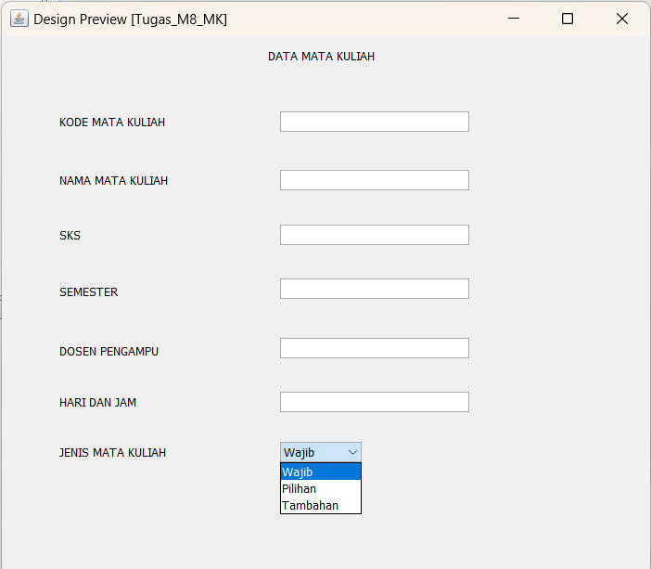

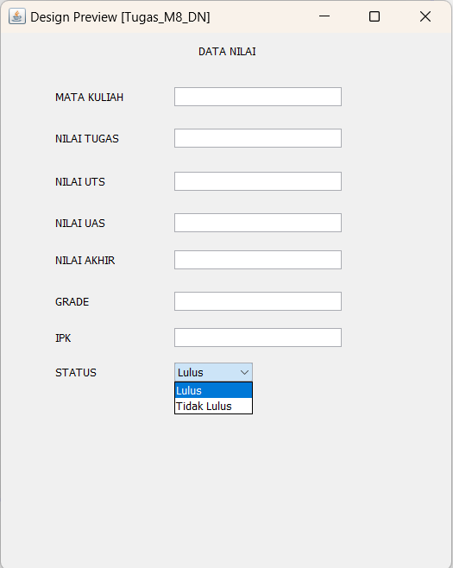

1. Buat table baru (mk dan nilai) di database yang sudah di buat pada modul 6

**Table mk**

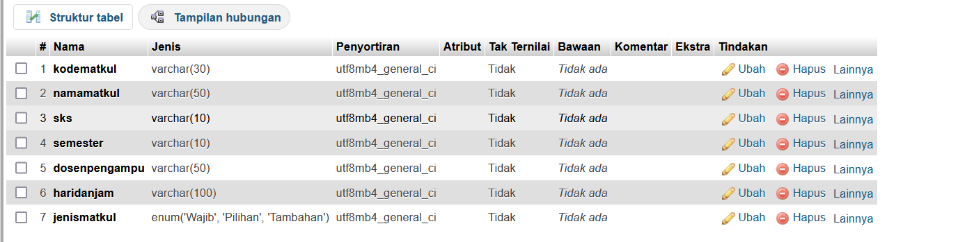

**Table nilai**

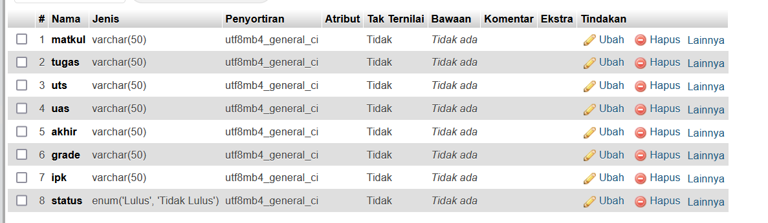

1. Lengkapi CRUD pada masing masing form (no.1)

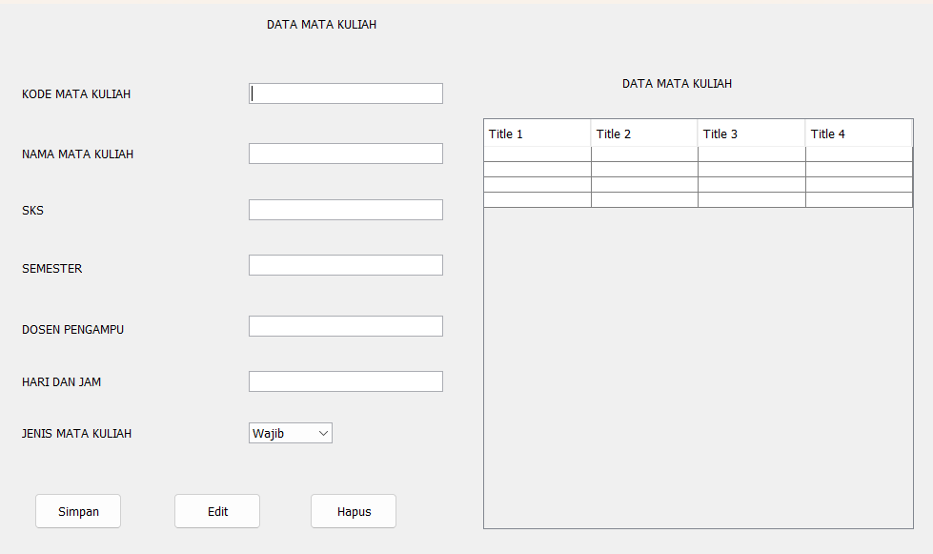

**Code Data Mata Kuliah**

/*

* To change this license header, choose License Headers in Project Properties.

* To change this template file, choose Tools | Templates

* and open the template in the editor.

*/

import java.sql.ResultSet;

import java.sql.SQLException;

import java.sql.Statement;

import javax.swing.JOptionPane;

import javax.swing.table.DefaultTableModel;

/**

*

* @author Suci Indah Lestari

*/

public class Tugas_M8_MK extends javax.swing.JFrame {

private Object JTable1;

Statement st;

ResultSet rs;

koneksi koneksi;

/**

* Creates new form BP1_M6_P1_aban

*/

Tugas_M8_MK() {

initComponents();

koneksi = new koneksi(); // Inisialisasi koneksi

load_data();

}

private void load_data() {

Object header[] = {"Kode Mata Kuliah", "Nama Mata Kuliah", "SKS", "Semester", "Dosen Pengampu", "Hari Dan Jam", "Jenis Mata Kuliah"};

DefaultTableModel data = new DefaultTableModel(null, header);

jTable1.setModel(data);

String sql = "SELECT kodematkul, namamatkul, sks, semester, dosenpengampu, haridanjam, jenismatkul FROM data_matkul";

try{

st = koneksi.con.createStatement();

rs = st.executeQuery(sql);

while(rs.next()){

String k1 = rs.getString("kodematkul");

String k2 = rs.getString("namamatkul");

String k3 = rs.getString("sks");

String k4 = rs.getString("semester");

String k5 = rs.getString("dosenpengampu");

String k6 = rs.getString("haridanjam");

String k7 = rs.getString("jenismatkul");

String k[] = {k1, k2, k3, k4, k5, k6, k7};

data.addRow(k);

}

} catch (Exception e) {

JOptionPane.showMessageDialog(null, e);

}

}

public void InputData() {

try {

// Validasi input

if (jTextField1.getText().isEmpty() || jTextField2.getText().isEmpty() || jTextField3.getText().isEmpty()

|| jTextField4.getText().isEmpty() || jTextField5.getText().isEmpty() || jTextField6.getText().isEmpty()

|| jComboBox1.getSelectedIndex() == 0) {

JOptionPane.showMessageDialog(this, "Registrasi Gagal, Data Harus Lengkap", "Error",

JOptionPane.ERROR_MESSAGE);

return;

}

String sql = "INSERT INTO data_matkul (kodematkul, namamatkul, sks, semester, dosenpengampu, haridanjam, jenismatkul) VALUES ('"

+ jTextField1.getText() + "', '" + jTextField2.getText() + "', '" + jTextField3.getText() + "', '"

+ jTextField4.getText() + "', '" + jTextField5.getText() + "', '" + jTextField6.getText() + "', '"

+ jComboBox1.getSelectedItem() + "')";

// Opsi Simpan Data

int Opsi = JOptionPane.showConfirmDialog(this, "Apakah Anda Akan Menyimpan Data?", "Konfirmasi",

JOptionPane.YES_NO_OPTION);

if (Opsi == JOptionPane.YES_OPTION) {

st = koneksi.con.createStatement(); // Pastikan statement dibuat sebelum eksekusi

st.executeUpdate(sql);

JOptionPane.showMessageDialog(this, "Data berhasil disimpan.");

clear_data();

} else {

JOptionPane.showMessageDialog(this, "Data tidak disimpan.");

}

} catch (SQLException e) {

JOptionPane.showMessageDialog(this, "Gagal Menyimpan Data: " + e.getMessage(), "Error", JOptionPane.ERROR_MESSAGE);

}

}

private void clear_data() {

jTextField1.setText("");

jTextField2.setText("");

jTextField3.setText("");

jTextField4.setText("");

jTextField5.setText("");

jTextField6.setText("");

jComboBox1.setSelectedIndex(0);

}

/**

*

* @author Suci Indah Lestari

*/

/**

* Creates new form Tugas_M8_MK

*/

/**

* This method is called from within the constructor to initialize the form.

* WARNING: Do NOT modify this code. The content of this method is always

* regenerated by the Form Editor.

*/

@SuppressWarnings("unchecked")

// <editor-fold defaultstate="collapsed" desc="Generated Code">

private void initComponents() {

jLabel1 = new javax.swing.JLabel();

jLabel2 = new javax.swing.JLabel();

jLabel3 = new javax.swing.JLabel();

jLabel4 = new javax.swing.JLabel();

jLabel5 = new javax.swing.JLabel();

jLabel6 = new javax.swing.JLabel();

jLabel7 = new javax.swing.JLabel();

jLabel8 = new javax.swing.JLabel();

jTextField1 = new javax.swing.JTextField();

jTextField2 = new javax.swing.JTextField();

jTextField3 = new javax.swing.JTextField();

jTextField4 = new javax.swing.JTextField();

jTextField5 = new javax.swing.JTextField();

jTextField6 = new javax.swing.JTextField();

jComboBox1 = new javax.swing.JComboBox<>();

jScrollPane1 = new javax.swing.JScrollPane();

jTable1 = new javax.swing.JTable();

jLabel9 = new javax.swing.JLabel();

jButton1 = new javax.swing.JButton();

jButton2 = new javax.swing.JButton();

jButton3 = new javax.swing.JButton();

setDefaultCloseOperation(javax.swing.WindowConstants.EXIT_ON_CLOSE);

jLabel1.setText("DATA MATA KULIAH");

jLabel2.setText("KODE MATA KULIAH");

jLabel3.setText("NAMA MATA KULIAH");

jLabel4.setText("SKS");

jLabel5.setText("SEMESTER");

jLabel6.setText("DOSEN PENGAMPU");

jLabel7.setText("HARI DAN JAM ");

jLabel8.setText("JENIS MATA KULIAH");

jTextField1.addActionListener(new java.awt.event.ActionListener() {

public void actionPerformed(java.awt.event.ActionEvent evt) {

jTextField1ActionPerformed(evt);

}

});

jTextField5.addActionListener(new java.awt.event.ActionListener() {

public void actionPerformed(java.awt.event.ActionEvent evt) {

jTextField5ActionPerformed(evt);

}

});

jTextField6.addActionListener(new java.awt.event.ActionListener() {

public void actionPerformed(java.awt.event.ActionEvent evt) {

jTextField6ActionPerformed(evt);

}

});

jComboBox1.setModel(new javax.swing.DefaultComboBoxModel<>(new String[] { "Wajib", "Pilihan", "Tambahan" }));

jTable1.setModel(new javax.swing.table.DefaultTableModel(

new Object [][] {

{null, null, null, null},

{null, null, null, null},

{null, null, null, null},

{null, null, null, null}

},

new String [] {

"Title 1", "Title 2", "Title 3", "Title 4"

}

));

jScrollPane1.setViewportView(jTable1);

jLabel9.setText("DATA MATA KULIAH");

jButton1.setText("Simpan");

jButton1.addMouseListener(new java.awt.event.MouseAdapter() {

public void mouseClicked(java.awt.event.MouseEvent evt) {

jButton1MouseClicked(evt);

}

});

jButton2.setText("Edit");

jButton2.addMouseListener(new java.awt.event.MouseAdapter() {

public void mouseClicked(java.awt.event.MouseEvent evt) {

jButton2MouseClicked(evt);

}

});

jButton3.setText("Hapus");

jButton3.addMouseListener(new java.awt.event.MouseAdapter() {

public void mouseClicked(java.awt.event.MouseEvent evt) {

jButton3MouseClicked(evt);

}

});

javax.swing.GroupLayout layout = new javax.swing.GroupLayout(getContentPane());

getContentPane().setLayout(layout);

layout.setHorizontalGroup(

layout.createParallelGroup(javax.swing.GroupLayout.Alignment.LEADING)

.addGroup(layout.createSequentialGroup()

.addGap(287, 287, 287)

.addComponent(jLabel1)

.addContainerGap(590, Short.MAX_VALUE))

.addGroup(layout.createSequentialGroup()

.addGroup(layout.createParallelGroup(javax.swing.GroupLayout.Alignment.LEADING)

.addGroup(layout.createSequentialGroup()

.addGap(30, 30, 30)

.addGroup(layout.createParallelGroup(javax.swing.GroupLayout.Alignment.TRAILING, false)

.addGroup(javax.swing.GroupLayout.Alignment.LEADING, layout.createSequentialGroup()

.addComponent(jLabel6)

.addPreferredGap(javax.swing.LayoutStyle.ComponentPlacement.RELATED, javax.swing.GroupLayout.DEFAULT_SIZE, Short.MAX_VALUE)

.addComponent(jTextField5, javax.swing.GroupLayout.PREFERRED_SIZE, 204, javax.swing.GroupLayout.PREFERRED_SIZE))

.addGroup(javax.swing.GroupLayout.Alignment.LEADING, layout.createSequentialGroup()

.addComponent(jLabel5)

.addPreferredGap(javax.swing.LayoutStyle.ComponentPlacement.RELATED, javax.swing.GroupLayout.DEFAULT_SIZE, Short.MAX_VALUE)

.addComponent(jTextField4, javax.swing.GroupLayout.PREFERRED_SIZE, 204, javax.swing.GroupLayout.PREFERRED_SIZE))

.addGroup(javax.swing.GroupLayout.Alignment.LEADING, layout.createSequentialGroup()

.addComponent(jLabel4)

.addPreferredGap(javax.swing.LayoutStyle.ComponentPlacement.RELATED, javax.swing.GroupLayout.DEFAULT_SIZE, Short.MAX_VALUE)

.addComponent(jTextField3, javax.swing.GroupLayout.PREFERRED_SIZE, 204, javax.swing.GroupLayout.PREFERRED_SIZE))

.addGroup(layout.createSequentialGroup()

.addComponent(jLabel3)

.addPreferredGap(javax.swing.LayoutStyle.ComponentPlacement.RELATED, javax.swing.GroupLayout.DEFAULT_SIZE, Short.MAX_VALUE)

.addComponent(jTextField2, javax.swing.GroupLayout.PREFERRED_SIZE, 204, javax.swing.GroupLayout.PREFERRED_SIZE))

.addGroup(layout.createSequentialGroup()

.addComponent(jLabel2)

.addGap(124, 124, 124)

.addComponent(jTextField1, javax.swing.GroupLayout.PREFERRED_SIZE, 204, javax.swing.GroupLayout.PREFERRED_SIZE))

.addGroup(layout.createSequentialGroup()

.addGroup(layout.createParallelGroup(javax.swing.GroupLayout.Alignment.LEADING)

.addComponent(jLabel7)

.addComponent(jLabel8))

.addPreferredGap(javax.swing.LayoutStyle.ComponentPlacement.RELATED, javax.swing.GroupLayout.DEFAULT_SIZE, Short.MAX_VALUE)

.addGroup(layout.createParallelGroup(javax.swing.GroupLayout.Alignment.LEADING)

.addComponent(jComboBox1, javax.swing.GroupLayout.PREFERRED_SIZE, javax.swing.GroupLayout.DEFAULT_SIZE, javax.swing.GroupLayout.PREFERRED_SIZE)

.addComponent(jTextField6, javax.swing.GroupLayout.PREFERRED_SIZE, 204, javax.swing.GroupLayout.PREFERRED_SIZE)))))

.addGroup(layout.createSequentialGroup()

.addGap(43, 43, 43)

.addComponent(jButton1, javax.swing.GroupLayout.PREFERRED_SIZE, 92, javax.swing.GroupLayout.PREFERRED_SIZE)

.addGap(54, 54, 54)

.addComponent(jButton2, javax.swing.GroupLayout.PREFERRED_SIZE, 92, javax.swing.GroupLayout.PREFERRED_SIZE)

.addGap(51, 51, 51)

.addComponent(jButton3, javax.swing.GroupLayout.PREFERRED_SIZE, 92, javax.swing.GroupLayout.PREFERRED_SIZE)))

.addGroup(layout.createParallelGroup(javax.swing.GroupLayout.Alignment.LEADING)

.addGroup(layout.createSequentialGroup()

.addPreferredGap(javax.swing.LayoutStyle.ComponentPlacement.RELATED, javax.swing.GroupLayout.DEFAULT_SIZE, Short.MAX_VALUE)

.addComponent(jScrollPane1, javax.swing.GroupLayout.PREFERRED_SIZE, javax.swing.GroupLayout.DEFAULT_SIZE, javax.swing.GroupLayout.PREFERRED_SIZE)

.addGap(26, 26, 26))

.addGroup(layout.createSequentialGroup()

.addGap(188, 188, 188)

.addComponent(jLabel9)

.addContainerGap(javax.swing.GroupLayout.DEFAULT_SIZE, Short.MAX_VALUE))))

);

layout.setVerticalGroup(

layout.createParallelGroup(javax.swing.GroupLayout.Alignment.LEADING)

.addGroup(layout.createSequentialGroup()

.addContainerGap()

.addComponent(jLabel1)

.addGroup(layout.createParallelGroup(javax.swing.GroupLayout.Alignment.LEADING)

.addGroup(javax.swing.GroupLayout.Alignment.TRAILING, layout.createSequentialGroup()

.addPreferredGap(javax.swing.LayoutStyle.ComponentPlacement.RELATED, 46, Short.MAX_VALUE)

.addComponent(jLabel9)

.addGap(29, 29, 29)

.addComponent(jScrollPane1, javax.swing.GroupLayout.PREFERRED_SIZE, javax.swing.GroupLayout.DEFAULT_SIZE, javax.swing.GroupLayout.PREFERRED_SIZE))

.addGroup(layout.createSequentialGroup()

.addGap(54, 54, 54)

.addGroup(layout.createParallelGroup(javax.swing.GroupLayout.Alignment.TRAILING)

.addGroup(layout.createSequentialGroup()

.addGroup(layout.createParallelGroup(javax.swing.GroupLayout.Alignment.TRAILING)

.addGroup(layout.createSequentialGroup()

.addGroup(layout.createParallelGroup(javax.swing.GroupLayout.Alignment.BASELINE)

.addComponent(jLabel2)

.addComponent(jTextField1, javax.swing.GroupLayout.PREFERRED_SIZE, javax.swing.GroupLayout.DEFAULT_SIZE, javax.swing.GroupLayout.PREFERRED_SIZE))

.addGap(41, 41, 41)

.addGroup(layout.createParallelGroup(javax.swing.GroupLayout.Alignment.BASELINE)

.addComponent(jLabel3)

.addComponent(jTextField2, javax.swing.GroupLayout.PREFERRED_SIZE, javax.swing.GroupLayout.DEFAULT_SIZE, javax.swing.GroupLayout.PREFERRED_SIZE))

.addGap(37, 37, 37)

.addGroup(layout.createParallelGroup(javax.swing.GroupLayout.Alignment.BASELINE)

.addComponent(jLabel4)

.addComponent(jTextField3, javax.swing.GroupLayout.PREFERRED_SIZE, javax.swing.GroupLayout.DEFAULT_SIZE, javax.swing.GroupLayout.PREFERRED_SIZE))

.addGap(42, 42, 42)

.addComponent(jLabel5))

.addComponent(jTextField4, javax.swing.GroupLayout.PREFERRED_SIZE, javax.swing.GroupLayout.DEFAULT_SIZE, javax.swing.GroupLayout.PREFERRED_SIZE))

.addGap(48, 48, 48)

.addComponent(jLabel6))

.addComponent(jTextField5, javax.swing.GroupLayout.PREFERRED_SIZE, javax.swing.GroupLayout.DEFAULT_SIZE, javax.swing.GroupLayout.PREFERRED_SIZE))

.addGap(36, 36, 36)

.addGroup(layout.createParallelGroup(javax.swing.GroupLayout.Alignment.BASELINE)

.addComponent(jLabel7)

.addComponent(jTextField6, javax.swing.GroupLayout.PREFERRED_SIZE, javax.swing.GroupLayout.DEFAULT_SIZE, javax.swing.GroupLayout.PREFERRED_SIZE))

.addGap(32, 32, 32)

.addGroup(layout.createParallelGroup(javax.swing.GroupLayout.Alignment.BASELINE)

.addComponent(jLabel8)

.addComponent(jComboBox1, javax.swing.GroupLayout.PREFERRED_SIZE, javax.swing.GroupLayout.DEFAULT_SIZE, javax.swing.GroupLayout.PREFERRED_SIZE))

.addPreferredGap(javax.swing.LayoutStyle.ComponentPlacement.RELATED, javax.swing.GroupLayout.DEFAULT_SIZE, Short.MAX_VALUE)

.addGroup(layout.createParallelGroup(javax.swing.GroupLayout.Alignment.BASELINE)

.addComponent(jButton1, javax.swing.GroupLayout.PREFERRED_SIZE, 38, javax.swing.GroupLayout.PREFERRED_SIZE)

.addComponent(jButton2, javax.swing.GroupLayout.PREFERRED_SIZE, 38, javax.swing.GroupLayout.PREFERRED_SIZE)

.addComponent(jButton3, javax.swing.GroupLayout.PREFERRED_SIZE, 38, javax.swing.GroupLayout.PREFERRED_SIZE))))

.addGap(30, 30, 30))

);

pack();

}// </editor-fold>

private void jTextField1ActionPerformed(java.awt.event.ActionEvent evt) {

// TODO add your handling code here:

}

private void jTextField5ActionPerformed(java.awt.event.ActionEvent evt) {

// TODO add your handling code here:

}

private void jTextField6ActionPerformed(java.awt.event.ActionEvent evt) {

// TODO add your handling code here:

}

private void jButton1MouseClicked(java.awt.event.MouseEvent evt) {

// TODO add your handling code here:

InputData();

clear_data();

load_data();

}

private void jButton2MouseClicked(java.awt.event.MouseEvent evt) {

// TODO add your handling code here:

try {

// SQL Update Statement

String sql_edit = "UPDATE data_matkul SET " +

"kodematkul = '" + jTextField1.getText() + "', " +

"namamatkul = '" + jTextField2.getText() + "', " +

"sks = '" + jTextField3.getText() + "', " +

"semester = '" + jTextField4.getText() + "', " +

"dosenpengampu = '" + jTextField5.getText() + "', " +

"haridanjam = '" + jTextField6.getText() + "', " +

"jenismatkul = '" + jComboBox1.getSelectedItem() + "' " ;

// Eksekusi update

int Opsi = JOptionPane.showConfirmDialog(this, "Apakah Anda Akan Edit Data?", "Konfirmasi",

JOptionPane.YES_NO_OPTION);

if (Opsi == JOptionPane.YES_OPTION) {

st.execute(sql_edit);

JOptionPane.showMessageDialog(this, "Data Berhasil Diedit.");

clear_data();

} else {

JOptionPane.showMessageDialog(this, "Data Tidak Diedit.");

}

} catch (SQLException e) {

JOptionPane.showMessageDialog(this, e.getMessage(), "Error", JOptionPane.ERROR_MESSAGE);

}

load_data();

}

private void jButton3MouseClicked(java.awt.event.MouseEvent evt) {

// TODO add your handling code here:

try{

st = koneksi.con.createStatement();

String sql_delete = "DELETE FROM data_matkul WHERE kodematkul = '" + jTextField1.getText()+"'";

int Opsi = JOptionPane.showConfirmDialog(this, "Apakah Anda Akan Hapus Data?", "Konfirmasi",

JOptionPane.YES_NO_OPTION);

if (Opsi == JOptionPane.YES_OPTION) {

st.execute(sql_delete);

JOptionPane.showMessageDialog(this, "Data Berhasil Dihapus.");

clear_data(); // Bersihkan inputan setelah data disimpan

} else {

JOptionPane.showMessageDialog(this, "Data Tidak Dihapus.");

}

} catch (SQLException e){

JOptionPane.showMessageDialog(null, e);

}

load_data();

}

/**

* @param args the command line arguments

*/

public static void main(String args[]) {

/* Set the Nimbus look and feel */

//<editor-fold defaultstate="collapsed" desc=" Look and feel setting code (optional) ">

/* If Nimbus (introduced in Java SE 6) is not available, stay with the default look and feel.

* For details see http://download.oracle.com/javase/tutorial/uiswing/lookandfeel/plaf.html

*/

try {

for (javax.swing.UIManager.LookAndFeelInfo info : javax.swing.UIManager.getInstalledLookAndFeels()) {

if ("Nimbus".equals(info.getName())) {

javax.swing.UIManager.setLookAndFeel(info.getClassName());

break;

}

}

} catch (ClassNotFoundException ex) {

java.util.logging.Logger.getLogger(Tugas_M8_MK.class.getName()).log(java.util.logging.Level.SEVERE, null, ex);

} catch (InstantiationException ex) {

java.util.logging.Logger.getLogger(Tugas_M8_MK.class.getName()).log(java.util.logging.Level.SEVERE, null, ex);

} catch (IllegalAccessException ex) {

java.util.logging.Logger.getLogger(Tugas_M8_MK.class.getName()).log(java.util.logging.Level.SEVERE, null, ex);

} catch (javax.swing.UnsupportedLookAndFeelException ex) {

java.util.logging.Logger.getLogger(Tugas_M8_MK.class.getName()).log(java.util.logging.Level.SEVERE, null, ex);

}

//</editor-fold>

/* Create and display the form */

java.awt.EventQueue.invokeLater(new Runnable() {

public void run() {

new Tugas_M8_MK().setVisible(true);

}

});

}

// Variables declaration - do not modify

private javax.swing.JButton jButton1;

private javax.swing.JButton jButton2;

private javax.swing.JButton jButton3;

private javax.swing.JComboBox<String> jComboBox1;

private javax.swing.JLabel jLabel1;

private javax.swing.JLabel jLabel2;

private javax.swing.JLabel jLabel3;

private javax.swing.JLabel jLabel4;

private javax.swing.JLabel jLabel5;

private javax.swing.JLabel jLabel6;

private javax.swing.JLabel jLabel7;

private javax.swing.JLabel jLabel8;

private javax.swing.JLabel jLabel9;

private javax.swing.JScrollPane jScrollPane1;

private javax.swing.JTable jTable1;

private javax.swing.JTextField jTextField1;

private javax.swing.JTextField jTextField2;

private javax.swing.JTextField jTextField3;

private javax.swing.JTextField jTextField4;

private javax.swing.JTextField jTextField5;

private javax.swing.JTextField jTextField6;

// End of variables declaration

}

**Table Nilai**

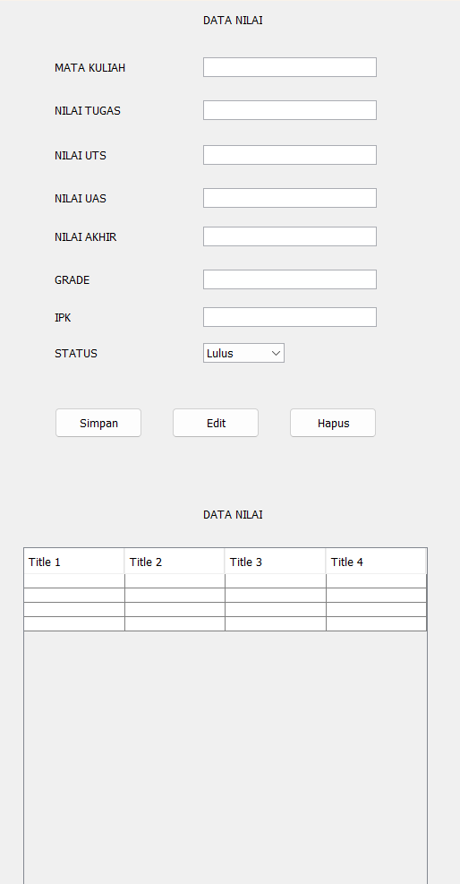

**Code Nilai**

/*

* To change this license header, choose License Headers in Project Properties.

* To change this template file, choose Tools | Templates

* and open the template in the editor.

*/

import java.sql.ResultSet;

import java.sql.SQLException;

import java.sql.Statement;

import javax.swing.JOptionPane;

import javax.swing.table.DefaultTableModel;

/**

*

* @author Suci Indah Lestari

*/

public class Tugas_M8_DN extends javax.swing.JFrame {

private Object JTable1;

Statement st;

ResultSet rs;

koneksi koneksi;

/**

* Creates new form BP1_M6_P1_aban

*/

Tugas_M8_DN() {

initComponents();

koneksi = new koneksi(); // Inisialisasi koneksi

load_data();

}

private void load_data() {

Object header[] = {"Mata Kuliah", "Nilai Tugas", "Nilai Uts", "Nilai Uas", "Nilai Akhir", "Grade", "IPK", "Status"};

DefaultTableModel data = new DefaultTableModel(null, header);

jTable1.setModel(data);

String sql = "SELECT matkul, tugas, uts, uas, akhir, grade, ipk, status FROM data_nilai";

try{

st = koneksi.con.createStatement();

rs = st.executeQuery(sql);

while(rs.next()){

String k1 = rs.getString("matkul");

String k2 = rs.getString("tugas");

String k3 = rs.getString("uts");

String k4 = rs.getString("uas");

String k5 = rs.getString("akhir");

String k6 = rs.getString("grade");

String k7 = rs.getString("ipk");

String k8 = rs.getString("status");

String k[] = {k1, k2, k3, k4, k5, k6, k7, k8};

data.addRow(k);

}

} catch (Exception e) {

JOptionPane.showMessageDialog(null, e);

}

}

public void InputData() {

try {

// Validasi input

if (jTextField1.getText().isEmpty() || jTextField2.getText().isEmpty() || jTextField3.getText().isEmpty()

|| jTextField4.getText().isEmpty() || jTextField5.getText().isEmpty() || jTextField6.getText().isEmpty()

|| jTextField7.getText().isEmpty() || jComboBox1.getSelectedIndex() == 0) {

JOptionPane.showMessageDialog(this, "Registrasi Gagal, Data Harus Lengkap", "Error",

JOptionPane.ERROR_MESSAGE);

return;

}

String sql = "INSERT INTO data_nilai (matkul, tugas, uts, uas, akhir, grade, ipk, status) VALUES ('"

+ jTextField1.getText() + "', '" + jTextField2.getText() + "', '" + jTextField3.getText() + "', '"

+ jTextField4.getText() + "', '" + jTextField5.getText() + "', '" + jTextField6.getText() + "', '"

+ jTextField7.getText() + "', '" + jComboBox1.getSelectedItem() + "')";

// Opsi Simpan Data

int Opsi = JOptionPane.showConfirmDialog(this, "Apakah Anda Akan Menyimpan Data?", "Konfirmasi",

JOptionPane.YES_NO_OPTION);

if (Opsi == JOptionPane.YES_OPTION) {

st = koneksi.con.createStatement(); // Pastikan statement dibuat sebelum eksekusi

st.executeUpdate(sql);

JOptionPane.showMessageDialog(this, "Data berhasil disimpan.");

clear_data();

} else {

JOptionPane.showMessageDialog(this, "Data tidak disimpan.");

}

} catch (SQLException e) {

JOptionPane.showMessageDialog(this, "Gagal Menyimpan Data: " + e.getMessage(), "Error", JOptionPane.ERROR_MESSAGE);

}

}

private void clear_data() {

jTextField1.setText("");

jTextField2.setText("");

jTextField3.setText("");

jTextField4.setText("");

jTextField5.setText("");

jTextField6.setText("");

jTextField7.setText("");

jComboBox1.setSelectedIndex(0);

}

/**

* This method is called from within the constructor to initialize the form.

* WARNING: Do NOT modify this code. The content of this method is always

* regenerated by the Form Editor.

*/

@SuppressWarnings("unchecked")

// <editor-fold defaultstate="collapsed" desc="Generated Code">

private void initComponents() {

jLabel1 = new javax.swing.JLabel();

jLabel2 = new javax.swing.JLabel();

jLabel3 = new javax.swing.JLabel();

jLabel4 = new javax.swing.JLabel();

jLabel5 = new javax.swing.JLabel();

jLabel6 = new javax.swing.JLabel();

jLabel7 = new javax.swing.JLabel();

jLabel8 = new javax.swing.JLabel();

jLabel9 = new javax.swing.JLabel();

jTextField1 = new javax.swing.JTextField();

jTextField2 = new javax.swing.JTextField();

jTextField3 = new javax.swing.JTextField();

jTextField4 = new javax.swing.JTextField();

jTextField5 = new javax.swing.JTextField();

jTextField6 = new javax.swing.JTextField();

jTextField7 = new javax.swing.JTextField();

jComboBox1 = new javax.swing.JComboBox<>();

jScrollPane1 = new javax.swing.JScrollPane();

jTable1 = new javax.swing.JTable();

jLabel10 = new javax.swing.JLabel();

jButton1 = new javax.swing.JButton();

jButton2 = new javax.swing.JButton();

jButton3 = new javax.swing.JButton();

setDefaultCloseOperation(javax.swing.WindowConstants.EXIT_ON_CLOSE);

jLabel1.setText("DATA NILAI");

jLabel2.setText("MATA KULIAH");

jLabel3.setText("NILAI TUGAS");

jLabel4.setText("NILAI UTS");

jLabel5.setText("NILAI UAS");

jLabel6.setText("NILAI AKHIR");

jLabel7.setText("GRADE");

jLabel8.setText("IPK");

jLabel9.setText("STATUS");

jTextField1.addActionListener(new java.awt.event.ActionListener() {

public void actionPerformed(java.awt.event.ActionEvent evt) {

jTextField1ActionPerformed(evt);

}

});

jTextField2.addActionListener(new java.awt.event.ActionListener() {

public void actionPerformed(java.awt.event.ActionEvent evt) {

jTextField2ActionPerformed(evt);

}

});

jTextField3.addActionListener(new java.awt.event.ActionListener() {

public void actionPerformed(java.awt.event.ActionEvent evt) {

jTextField3ActionPerformed(evt);

}

});

jTextField4.addActionListener(new java.awt.event.ActionListener() {

public void actionPerformed(java.awt.event.ActionEvent evt) {

jTextField4ActionPerformed(evt);

}

});

jTextField5.addActionListener(new java.awt.event.ActionListener() {

public void actionPerformed(java.awt.event.ActionEvent evt) {

jTextField5ActionPerformed(evt);

}

});

jTextField6.addActionListener(new java.awt.event.ActionListener() {

public void actionPerformed(java.awt.event.ActionEvent evt) {

jTextField6ActionPerformed(evt);

}

});

jTextField7.addActionListener(new java.awt.event.ActionListener() {

public void actionPerformed(java.awt.event.ActionEvent evt) {

jTextField7ActionPerformed(evt);

}

});

jComboBox1.setModel(new javax.swing.DefaultComboBoxModel<>(new String[] { "Lulus", "Tidak Lulus" }));

jComboBox1.addActionListener(new java.awt.event.ActionListener() {

public void actionPerformed(java.awt.event.ActionEvent evt) {

jComboBox1ActionPerformed(evt);

}

});

jTable1.setModel(new javax.swing.table.DefaultTableModel(

new Object [][] {

{null, null, null, null},

{null, null, null, null},

{null, null, null, null},

{null, null, null, null}

},

new String [] {

"Title 1", "Title 2", "Title 3", "Title 4"

}

));

jScrollPane1.setViewportView(jTable1);

jLabel10.setText("DATA NILAI");

jButton1.setText("Simpan");

jButton1.addMouseListener(new java.awt.event.MouseAdapter() {

public void mouseClicked(java.awt.event.MouseEvent evt) {

jButton1MouseClicked(evt);

}

});

jButton2.setText("Edit");

jButton2.addMouseListener(new java.awt.event.MouseAdapter() {

public void mouseClicked(java.awt.event.MouseEvent evt) {

jButton2MouseClicked(evt);

}

});

jButton3.setText("Hapus");

jButton3.addMouseListener(new java.awt.event.MouseAdapter() {

public void mouseClicked(java.awt.event.MouseEvent evt) {

jButton3MouseClicked(evt);

}

});

javax.swing.GroupLayout layout = new javax.swing.GroupLayout(getContentPane());

getContentPane().setLayout(layout);

layout.setHorizontalGroup(

layout.createParallelGroup(javax.swing.GroupLayout.Alignment.LEADING)

.addGroup(layout.createSequentialGroup()

.addGroup(layout.createParallelGroup(javax.swing.GroupLayout.Alignment.LEADING)

.addGroup(layout.createSequentialGroup()

.addGap(229, 229, 229)

.addComponent(jLabel1))

.addGroup(layout.createSequentialGroup()

.addGap(63, 63, 63)

.addGroup(layout.createParallelGroup(javax.swing.GroupLayout.Alignment.LEADING)

.addGroup(layout.createSequentialGroup()

.addComponent(jLabel2)

.addPreferredGap(javax.swing.LayoutStyle.ComponentPlacement.RELATED, 87, Short.MAX_VALUE)

.addComponent(jTextField1, javax.swing.GroupLayout.PREFERRED_SIZE, 194, javax.swing.GroupLayout.PREFERRED_SIZE))

.addGroup(layout.createSequentialGroup()

.addGroup(layout.createParallelGroup(javax.swing.GroupLayout.Alignment.TRAILING)

.addComponent(jLabel3)

.addGroup(javax.swing.GroupLayout.Alignment.LEADING, layout.createParallelGroup(javax.swing.GroupLayout.Alignment.TRAILING)

.addComponent(jLabel4)

.addComponent(jLabel5))

.addComponent(jLabel6, javax.swing.GroupLayout.Alignment.LEADING)

.addComponent(jLabel7, javax.swing.GroupLayout.Alignment.LEADING)

.addComponent(jLabel8, javax.swing.GroupLayout.Alignment.LEADING)

.addComponent(jLabel9, javax.swing.GroupLayout.Alignment.LEADING))

.addPreferredGap(javax.swing.LayoutStyle.ComponentPlacement.RELATED, javax.swing.GroupLayout.DEFAULT_SIZE, Short.MAX_VALUE)

.addGroup(layout.createParallelGroup(javax.swing.GroupLayout.Alignment.LEADING)

.addComponent(jTextField2, javax.swing.GroupLayout.Alignment.TRAILING, javax.swing.GroupLayout.PREFERRED_SIZE, 194, javax.swing.GroupLayout.PREFERRED_SIZE)

.addComponent(jTextField3, javax.swing.GroupLayout.Alignment.TRAILING, javax.swing.GroupLayout.PREFERRED_SIZE, 194, javax.swing.GroupLayout.PREFERRED_SIZE)

.addComponent(jTextField4, javax.swing.GroupLayout.Alignment.TRAILING, javax.swing.GroupLayout.PREFERRED_SIZE, 194, javax.swing.GroupLayout.PREFERRED_SIZE)

.addGroup(javax.swing.GroupLayout.Alignment.TRAILING, layout.createParallelGroup(javax.swing.GroupLayout.Alignment.LEADING)

.addComponent(jTextField5, javax.swing.GroupLayout.Alignment.TRAILING, javax.swing.GroupLayout.PREFERRED_SIZE, 194, javax.swing.GroupLayout.PREFERRED_SIZE)

.addComponent(jTextField6, javax.swing.GroupLayout.PREFERRED_SIZE, 194, javax.swing.GroupLayout.PREFERRED_SIZE)

.addComponent(jTextField7, javax.swing.GroupLayout.PREFERRED_SIZE, 194, javax.swing.GroupLayout.PREFERRED_SIZE)

.addComponent(jComboBox1, javax.swing.GroupLayout.PREFERRED_SIZE, javax.swing.GroupLayout.DEFAULT_SIZE, javax.swing.GroupLayout.PREFERRED_SIZE)

.addComponent(jLabel10))))

.addGroup(layout.createSequentialGroup()

.addGroup(layout.createParallelGroup(javax.swing.GroupLayout.Alignment.LEADING)

.addGroup(layout.createSequentialGroup()

.addComponent(jButton1, javax.swing.GroupLayout.PREFERRED_SIZE, 98, javax.swing.GroupLayout.PREFERRED_SIZE)

.addPreferredGap(javax.swing.LayoutStyle.ComponentPlacement.RELATED, javax.swing.GroupLayout.DEFAULT_SIZE, Short.MAX_VALUE))

.addGroup(layout.createSequentialGroup()

.addGap(0, 0, Short.MAX_VALUE)

.addComponent(jButton2, javax.swing.GroupLayout.PREFERRED_SIZE, 98, javax.swing.GroupLayout.PREFERRED_SIZE)

.addGap(33, 33, 33)))

.addComponent(jButton3, javax.swing.GroupLayout.PREFERRED_SIZE, 98, javax.swing.GroupLayout.PREFERRED_SIZE)))))

.addGap(99, 99, 99))

.addGroup(layout.createSequentialGroup()

.addGap(28, 28, 28)

.addComponent(jScrollPane1, javax.swing.GroupLayout.PREFERRED_SIZE, javax.swing.GroupLayout.DEFAULT_SIZE, javax.swing.GroupLayout.PREFERRED_SIZE)

.addContainerGap(javax.swing.GroupLayout.DEFAULT_SIZE, Short.MAX_VALUE))

);

layout.setVerticalGroup(

layout.createParallelGroup(javax.swing.GroupLayout.Alignment.LEADING)

.addGroup(layout.createSequentialGroup()

.addContainerGap()

.addComponent(jLabel1)

.addGap(34, 34, 34)

.addGroup(layout.createParallelGroup(javax.swing.GroupLayout.Alignment.BASELINE)

.addComponent(jLabel2)

.addComponent(jTextField1, javax.swing.GroupLayout.PREFERRED_SIZE, javax.swing.GroupLayout.DEFAULT_SIZE, javax.swing.GroupLayout.PREFERRED_SIZE))

.addGap(26, 26, 26)

.addGroup(layout.createParallelGroup(javax.swing.GroupLayout.Alignment.BASELINE)

.addComponent(jLabel3)

.addComponent(jTextField2, javax.swing.GroupLayout.PREFERRED_SIZE, javax.swing.GroupLayout.DEFAULT_SIZE, javax.swing.GroupLayout.PREFERRED_SIZE))

.addGap(28, 28, 28)

.addGroup(layout.createParallelGroup(javax.swing.GroupLayout.Alignment.BASELINE)

.addComponent(jLabel4)

.addComponent(jTextField3, javax.swing.GroupLayout.PREFERRED_SIZE, javax.swing.GroupLayout.DEFAULT_SIZE, javax.swing.GroupLayout.PREFERRED_SIZE))

.addGap(26, 26, 26)

.addGroup(layout.createParallelGroup(javax.swing.GroupLayout.Alignment.BASELINE)

.addComponent(jLabel5)

.addComponent(jTextField4, javax.swing.GroupLayout.PREFERRED_SIZE, javax.swing.GroupLayout.DEFAULT_SIZE, javax.swing.GroupLayout.PREFERRED_SIZE))

.addGap(21, 21, 21)

.addGroup(layout.createParallelGroup(javax.swing.GroupLayout.Alignment.BASELINE)

.addComponent(jLabel6)

.addComponent(jTextField5, javax.swing.GroupLayout.PREFERRED_SIZE, javax.swing.GroupLayout.DEFAULT_SIZE, javax.swing.GroupLayout.PREFERRED_SIZE))

.addGap(26, 26, 26)

.addGroup(layout.createParallelGroup(javax.swing.GroupLayout.Alignment.BASELINE)

.addComponent(jLabel7)

.addComponent(jTextField6, javax.swing.GroupLayout.PREFERRED_SIZE, javax.swing.GroupLayout.DEFAULT_SIZE, javax.swing.GroupLayout.PREFERRED_SIZE))

.addGap(20, 20, 20)

.addGroup(layout.createParallelGroup(javax.swing.GroupLayout.Alignment.BASELINE)

.addComponent(jLabel8)

.addComponent(jTextField7, javax.swing.GroupLayout.PREFERRED_SIZE, javax.swing.GroupLayout.DEFAULT_SIZE, javax.swing.GroupLayout.PREFERRED_SIZE))

.addGap(18, 18, 18)

.addGroup(layout.createParallelGroup(javax.swing.GroupLayout.Alignment.BASELINE)

.addComponent(jLabel9)

.addComponent(jComboBox1, javax.swing.GroupLayout.PREFERRED_SIZE, javax.swing.GroupLayout.DEFAULT_SIZE, javax.swing.GroupLayout.PREFERRED_SIZE))

.addGap(50, 50, 50)

.addGroup(layout.createParallelGroup(javax.swing.GroupLayout.Alignment.BASELINE)

.addComponent(jButton1, javax.swing.GroupLayout.PREFERRED_SIZE, 34, javax.swing.GroupLayout.PREFERRED_SIZE)

.addComponent(jButton2, javax.swing.GroupLayout.PREFERRED_SIZE, 34, javax.swing.GroupLayout.PREFERRED_SIZE)

.addComponent(jButton3, javax.swing.GroupLayout.PREFERRED_SIZE, 34, javax.swing.GroupLayout.PREFERRED_SIZE))

.addPreferredGap(javax.swing.LayoutStyle.ComponentPlacement.RELATED, 77, Short.MAX_VALUE)

.addComponent(jLabel10)

.addGap(29, 29, 29)

.addComponent(jScrollPane1, javax.swing.GroupLayout.PREFERRED_SIZE, javax.swing.GroupLayout.DEFAULT_SIZE, javax.swing.GroupLayout.PREFERRED_SIZE)

.addContainerGap())

);

pack();

}// </editor-fold>

private void jTextField1ActionPerformed(java.awt.event.ActionEvent evt) {

// TODO add your handling code here:

}

private void jTextField2ActionPerformed(java.awt.event.ActionEvent evt) {

// TODO add your handling code here:

}

private void jTextField3ActionPerformed(java.awt.event.ActionEvent evt) {

// TODO add your handling code here:

}

private void jTextField4ActionPerformed(java.awt.event.ActionEvent evt) {

// TODO add your handling code here:

}

private void jTextField5ActionPerformed(java.awt.event.ActionEvent evt) {

// TODO add your handling code here:

}

private void jTextField6ActionPerformed(java.awt.event.ActionEvent evt) {

// TODO add your handling code here:

}

private void jTextField7ActionPerformed(java.awt.event.ActionEvent evt) {

// TODO add your handling code here:

}

private void jComboBox1ActionPerformed(java.awt.event.ActionEvent evt) {

// TODO add your handling code here:

}

private void jButton1MouseClicked(java.awt.event.MouseEvent evt) {

// TODO add your handling code here:

InputData();

clear_data();

load_data();

}

private void jButton2MouseClicked(java.awt.event.MouseEvent evt) {

// TODO add your handling code here:

try {

// SQL Update Statement

String sql_edit = "UPDATE data_nilai SET " +

"matkul = '" + jTextField1.getText() + "', " +

"tugas = '" + jTextField2.getText() + "', " +

"uts = '" + jTextField3.getText() + "', " +

"uas = '" + jTextField4.getText() + "', " +

"akhir = '" + jTextField5.getText() + "', " +

"grade = '" + jTextField6.getText() + "', " +

"ipk = '" + jTextField7.getText() + "', " +

"status = '" + jComboBox1.getSelectedItem() + "' " ;

// Eksekusi update

int Opsi = JOptionPane.showConfirmDialog(this, "Apakah Anda Akan Edit Data?", "Konfirmasi",

JOptionPane.YES_NO_OPTION);

if (Opsi == JOptionPane.YES_OPTION) {

st.execute(sql_edit);

JOptionPane.showMessageDialog(this, "Data Berhasil Diedit.");

clear_data();

} else {

JOptionPane.showMessageDialog(this, "Data Tidak Diedit.");

}

} catch (SQLException e) {

JOptionPane.showMessageDialog(this, e.getMessage(), "Error", JOptionPane.ERROR_MESSAGE);

}

load_data();

}

private void jButton3MouseClicked(java.awt.event.MouseEvent evt) {

// TODO add your handling code here:

try{

st = koneksi.con.createStatement();

String sql_delete = "DELETE FROM data_nilai WHERE matkul = '" + jTextField1.getText()+"'";

int Opsi = JOptionPane.showConfirmDialog(this, "Apakah Anda Akan Hapus Data?", "Konfirmasi",

JOptionPane.YES_NO_OPTION);

if (Opsi == JOptionPane.YES_OPTION) {

st.execute(sql_delete);

JOptionPane.showMessageDialog(this, "Data Berhasil Dihapus.");

clear_data(); // Bersihkan inputan setelah data disimpan

} else {

JOptionPane.showMessageDialog(this, "Data Tidak Dihapus.");

}

} catch (SQLException e){

JOptionPane.showMessageDialog(null, e);

}

load_data();

}

/**

* @param args the command line arguments

*/

public static void main(String args[]) {

/* Set the Nimbus look and feel */

//<editor-fold defaultstate="collapsed" desc=" Look and feel setting code (optional) ">

/* If Nimbus (introduced in Java SE 6) is not available, stay with the default look and feel.

* For details see http://download.oracle.com/javase/tutorial/uiswing/lookandfeel/plaf.html

*/

try {

for (javax.swing.UIManager.LookAndFeelInfo info : javax.swing.UIManager.getInstalledLookAndFeels()) {

if ("Nimbus".equals(info.getName())) {

javax.swing.UIManager.setLookAndFeel(info.getClassName());

break;

}

}

} catch (ClassNotFoundException ex) {

java.util.logging.Logger.getLogger(Tugas_M8_DN.class.getName()).log(java.util.logging.Level.SEVERE, null, ex);

} catch (InstantiationException ex) {

java.util.logging.Logger.getLogger(Tugas_M8_DN.class.getName()).log(java.util.logging.Level.SEVERE, null, ex);

} catch (IllegalAccessException ex) {

java.util.logging.Logger.getLogger(Tugas_M8_DN.class.getName()).log(java.util.logging.Level.SEVERE, null, ex);

} catch (javax.swing.UnsupportedLookAndFeelException ex) {

java.util.logging.Logger.getLogger(Tugas_M8_DN.class.getName()).log(java.util.logging.Level.SEVERE, null, ex);

}

//</editor-fold>

/* Create and display the form */

java.awt.EventQueue.invokeLater(new Runnable() {

public void run() {

new Tugas_M8_DN().setVisible(true);

}

});

}

// Variables declaration - do not modify

private javax.swing.JButton jButton1;

private javax.swing.JButton jButton2;

private javax.swing.JButton jButton3;

private javax.swing.JComboBox<String> jComboBox1;

private javax.swing.JLabel jLabel1;

private javax.swing.JLabel jLabel10;

private javax.swing.JLabel jLabel2;

private javax.swing.JLabel jLabel3;

private javax.swing.JLabel jLabel4;

private javax.swing.JLabel jLabel5;

private javax.swing.JLabel jLabel6;

private javax.swing.JLabel jLabel7;

private javax.swing.JLabel jLabel8;

private javax.swing.JLabel jLabel9;

private javax.swing.JScrollPane jScrollPane1;

private javax.swing.JTable jTable1;

private javax.swing.JTextField jTextField1;

private javax.swing.JTextField jTextField2;

private javax.swing.JTextField jTextField3;

private javax.swing.JTextField jTextField4;

private javax.swing.JTextField jTextField5;

private javax.swing.JTextField jTextField6;

private javax.swing.JTextField jTextField7;

// End of variables declaration

}

1. Buat form data nilai mahasiswa, yang menampilkan NIM,NAMA,JK,PRODI,KELAS,NILAI,PHOTO

